Task:03

1. CV XML

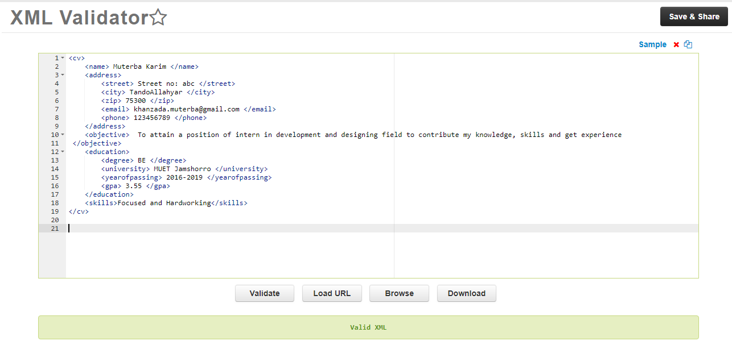

1. DPRT DATA XML

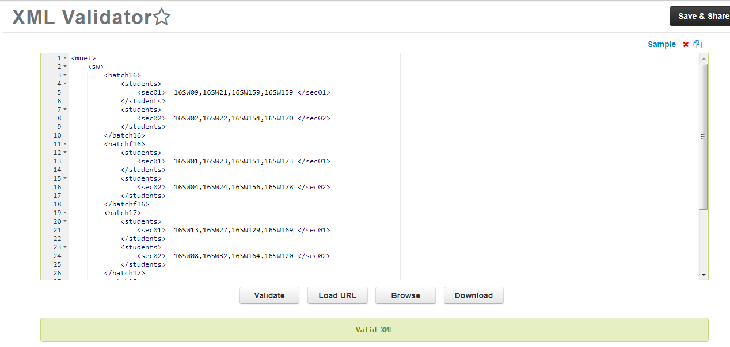

Task:04 Difference between XML and JSON.

|  |  |
| --- | --- |
| **XML** | **JSON** |
| The XML format has been around for some time, so there is a lot of software developed for it. | The JSON format is quite new, so there is a lot less support for it. |
| XML was developed as an independent data format. | JSON was developed specifically for use with Javascript and AJAX, so the format is exactly the same as a Javascript literal object (that is, it's a subset of the Javascript code, as it for example can't contain expressions to determine values). |
| XML is a meta-language/markup language. | JSON is a lightweight data-interchange. |
| XML syntax is designed specifically to have no inherent semantics. Particular element names don't mean anything until a particular processing application processes them in a particular way. | JSON syntax has specific semantics built in stuff between {} is an object, stuff between [] is an array, etc. |
| An XML parser only knows how to separate markup from data. To deal with the meaning of an XML document, you have to write additional code. | A JSON parser, therefore, knows exactly what every JSON document means. |